**Experiment:- Potentiometer**

**To Determine the Internal Resistance Of A Given Primary Cell Using A Potentiometer**

## Aim

To determine the internal resistance of a given primary cell using a Potentiometer.

## Materials Required

1. 1 galvanometer
2. A battery
3. 1 potentiometer
4. 1 rheostat of low resistance
5. A fractional resistance box
6. 1 ammeter
7. 2 numbers keys (one-way)
8. Connecting wires
9. A jockey
10. 1 high resistance box
11. Sandpaper
12. 1 Leclanche cell
13. 1 set square
14. 1 voltmeter

## Theory

The potentiometer is a device used to measure the internal resistance of a cell and is used to compare the EMF of two cells and potential difference across a resistor. The relation between potential difference, EMF, and internal resistance of a cell is given by

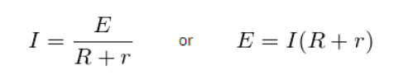

## The internal resistance of the cell is given by

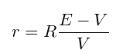

## Circuit Diagram

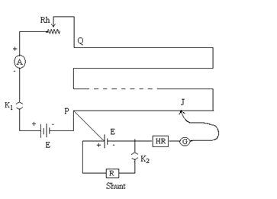

Here the internal resistance of the cell is given by

Determine The Internal Resistance Of A Given Primary Cell Using A Potentiometer-5

Where l1 and l2 are balancing lengths without shunt or with the shunt. R is the shunt resistance in parallel with the given cell.

## Procedure

1. The connections should be according to the diagram shown above.
2. Using sandpaper clean the ends of the connecting wires and make sure that the connections are tight.
3. The plugs in the resistance box should be tight.
4. The EMF of the cell and battery is more than that of the cell. If it is not then the null point won’t be obtained.
5. Rheostat resistance can be made minimum by taking maximum current from the battery.
6. To check if the circuit connections are correct, the galvanometer deflections should be in the opposite direction. This is done by inserting the key K1 and making note of ammeter reading.
7. To obtain the null point on the fourth wire, the rheostat should be adjusted without inserting the key K2.
8. Take the small resistance between 1-5 ohm from resistance box R connected in parallel with the cell.
9. Slide the jockey and obtain the null point
10. Record your observation.

## Observations

The least count of voltmeter = ………

Range of voltmeters = ……..

E.M.F of cell = ………

E.M.F of battery = ……

**Table for lengths**

|  |  |  |  |  |  |  |  |  |
| --- | --- | --- | --- | --- | --- | --- | --- | --- |
| S.No. | **Corrected ammeter reading (A)** | Balance point when E1 (Leclanche cell) in the circuit  l1 (cm) | | | Balance point when E2 (Daniel cell) in the circuit  l2 (cm) | | | **(E1/E2) = (l1/l2)** |
|  |  |  |  |  |  |  |  |  |
|  |  |  |  |  |  |  |  |  |
|  |  |  |  |  |  |  |  |  |
|  |  |  |  |  |  |  |  |  |

## Calculations

1. For each set of observation find mean and l2
2. Calculate the value of r for each set.
3. Take the mean of values of r.

## Result

The internal resistance of the given cell is found to be………

## Precautions

1. The e.m.f of the cell should be lesser than the battery.
2. Have an eye to make sure that the ammeter reading remains constant at least for a single set of readings.
3. Ensure the current is passed only while obtaining the null point.
4. The rheostat should be placed
5. During the experiment, the cell should not be disturbed.
6. There shouldn’t be rubbing of jockey against potentiometer wire.